**Identified code smells**

Team member number:

**Code smell 1 - Roundabout super call (not sure what the official name for this one is)**

**Code snippet**

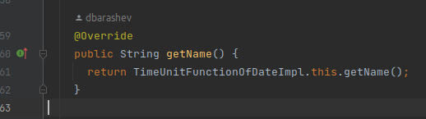

**The exact location on the codebase**

biz.ganttproject.core/src/main/java/biz/ganttproject/core/time/TimeUnitFunctionOfDateImpl.java

**Explanation of the rationale for identifying this code smell**

Calls it’s own class instead of just calling the superclass method with super.method().

**A refactoring proposal**

Returning super.getName();

**Code smell 2 – No Comments**

**Code snippet**

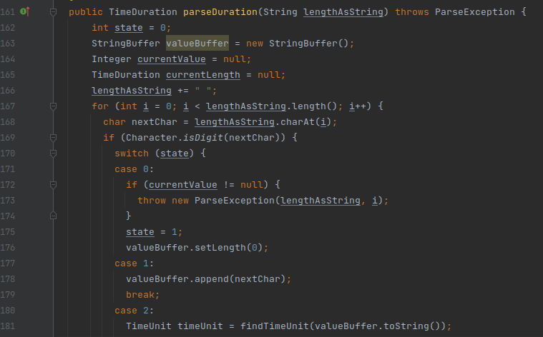

**The exact location on the codebase**

biz.ganttproject.core/src/main/java/biz/ganttproject/core/time/impl/GPTimeUnitStack.java

**Explanation of the rationale for identifying this code smell**

A distinct lack of comments on most of the code, making hard for anyone reading it to understand what it’s supposed to do at a glance.

**A refactoring proposal**

Add comments saying what some of the more complicated methods aim to do.

**Code smell 3 – Data Class**

**Code snippet**

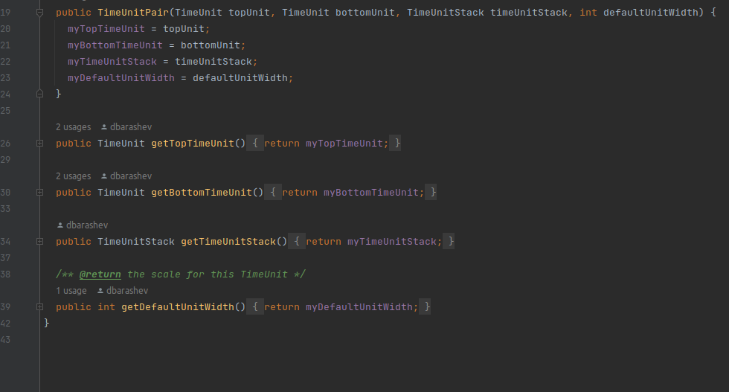

**The exact location on the codebase**

biz.ganttproject.core/src/main/java/biz/ganttproject/core/time/TimeUnitPair.java

**Explanation** **of the rationale for identifying this code smell**

This class only has getter methods, so it’s probably not a very necessary class

**A refactoring proposal**

We could add a few functionalities to maintain this class. Failing that, maybe exchange it for an array on GPTimeUnitStack.java, since it’s the only class that uses it.